IHCI Project Proposal

# Rules

* Submit a Google Doc, NOT a PDF or a Google slide.
* Use the default fonts, line spacing, and font size unless specifically required in the assignment.
* After submission, the Google Doc will get automatically locked, so you won't be able to make any changes.
* Standard plagiarism rules apply.
* Your submission will not be considered for grading and feedback if you do not follow these guidelines.

**Names of Group Members:**

| 2022346 | PANKAJ KUMAR |
| --- | --- |
| 2022347 | PANKAJ YADAV |
| 2022348 | PANKHURI SINGH |
| 2022349 | PARAS KAKRAN |
| 2022350 | PARAS VERMA |

**Project Group Number:2**

**HCI Group No.:3**

## **Requirement Gathering**

By the means of interviews and brainstorming, we have identified the following as the stakeholders of our application and what are their roles in the application:-

**1). Students who are in their 1st or 2nd year of college-**

Students who are in their first year in college are new to the studying culture of college which is completely different from the school which might give them a hard time.

By using this app the freshers can contact their seniors or even batchmates for discussing their academic doubts, arrange a class in person with them or get guidance about something other than academics.

**Role-** Their role is to post a request on the app regarding whatever their doubt is or on which topic they want an class on .

**2.) Students who are in 2nd 3rd or 4th year-:**

Students who are in their later years of college have already studied the courses of 1 st or 2nd year, so they can be helpful in solving the doubts of freshers or providing them with classes in person or guiding them through college life.

**Role-:**  Their role is to look up the queries of students and arrange a class for them on the said topic. Or they can even schedule a class on a random topic that they think is important and want to teach and post about it on the app so the interested students can join.

**3)Other Volunteers:**

Other Volunteers,such as graduate students or teachers, who are interested in teaching during their leisure time can also enjoy the benefits of this app once they provide information about some degree or course that they have done to authenticate their profile.

**Role:** Schedule classes for topics that they can teach or respond to queries of students asking for classes/doubts sessions of a subject they are interested in teaching.

**Expectations-**

These are the expectations of the user from the application-:

– It should be easy to sign up and get verified on the app.

_ The tutors should be trustworthy and helpful.

_ Posting requests for doubt-solving or a class should be a smooth process.

_ The Tutors expect that if they are taking a class, the students should be on time and respectful to them

_ There should not be any spam of any type and users trying to do any type of mischievous activities should be warned.

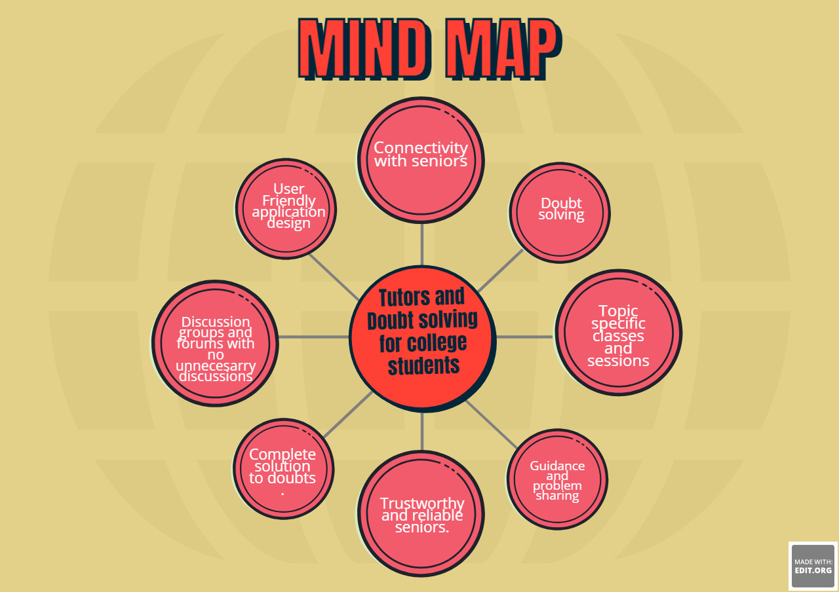

## **Personas and Scenarios**

<developing different user archetypes to understand and empathise with users through business and personal contexts>

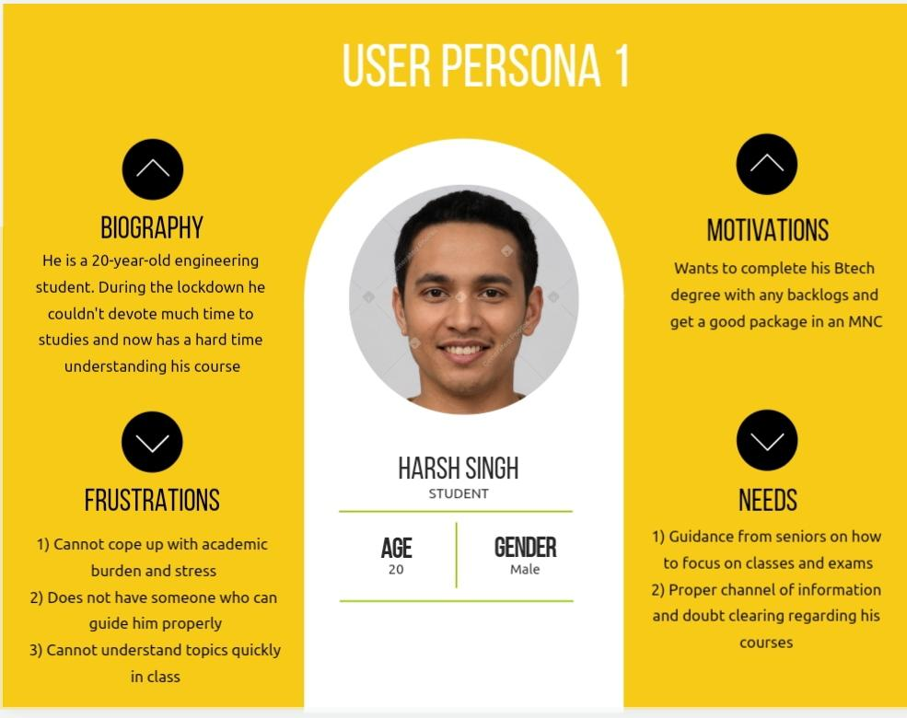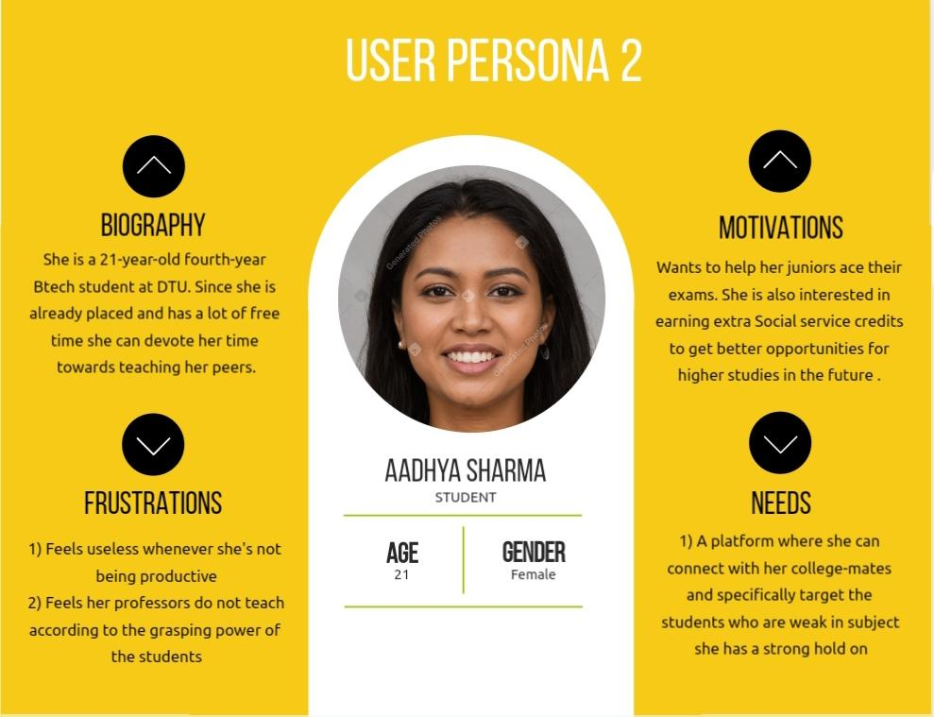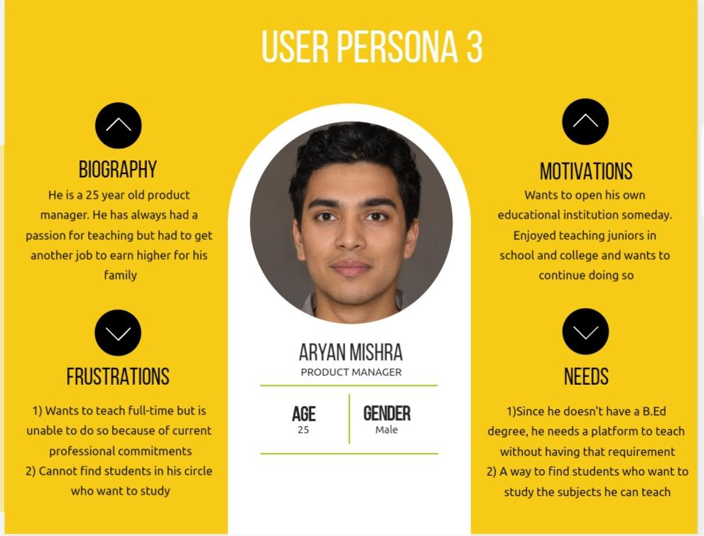

## **Problem Understanding**

From the information given above we understand that college students are under immense pressure and face a lot of difficulties in understanding their syllabus and new environment. They may need some extra help with their studies and since it is only natural that Professors and TA’s are not always available, it is ideal that people like their seniors and peers help them. The is exactly what our app ‘TutBuddy” aims to achieve. On the other hand experienced senior students willing to help others in return for social work credits or money can easily use this platform to find needy juniors/peers.

**HOW IT WILL WORK:**

**1)Step 1**: Students who need a query/topic resolved can post it on app . Tuting Volunteers can also post the topics they are willing to teach in a similar manner. They can also specify their preferred mode of classes- Online or Offline

**2)Step 2:** Students and Volunteers can see these posts on their feed if they are related to the topics they are interested in studying/teaching.

**3)Step 3:** Once the above two steps are completed ,users can then enroll themselves for that class or Offer to teach it. Classes can be held in a hybrid mode (both online or offline) as per the convenience of both the parties.

## 

## Contributions

1.Pankaj Kumar-Persona building

2.Pankaj Yadav-Persona building

3.Pankhuri Singh-Problem Understanding

4.Paras Kakran-Google form for interview process

5.Paras Verma-Requirement Gathering

*ALL IMAGES USED FOR PERSONAS HAVE BEEN TAKING FROM THE FOLLOWING SOURCE: <https://generated.photos/faces/latino-race/male> *